Adjustment of Sub-daily Rainfall to a Reference DDF
Site: TEST Generated: 2026-09-24 Tool: Mayim Tools - Adjust Sub-daily Rainfall to DDF
Reference: Tier 1 - published gauge-based DDF. Reference-based consistency check.

1. Purpose
Gridded reanalysis and satellite rainfall products (e.g. ERA5) represent grid-cell averages and, in the case of reanalyses, parameterised convection. Their short-duration (sub-daily) intensities are therefore typically lower than point (gauge) intensities, and the shortfall tends to grow towards rarer events. This report documents the adjustment of the input sub-daily series so that its annual-maximum depths at all tested durations are consistent with the supplied reference Depth-Duration-Frequency (DDF) table, while retaining the timing and sequence of the recorded storms.

2. Inputs
Item | Value
Rainfall series | synthetic.csv
Record analysed | 1980-01-01 00:00:00 to 2019-12-31 23:00:00
Native time step | 60 min
Complete years used | 40
Years excluded (completeness) | none
Time-zone offset applied | 2.0 h
Reference DDF | synthetic_ddf.csv
Reference tier | Tier 1 - published gauge-based DDF
Reference already areal (ARF applied) | False
Reference durations (min) | 60,120,180,360,720,1440,2880
Reference return periods (yr) | 2,5,10,20,50,100
Reference conversions | none
Distribution / fitting | GEV (L-moments)
Fixed-interval correction | Weiss (1964) 1/(1-1/(8n))
Storm separation | IETD 6.0 h, minimum depth 2.0 mm; 932 storms

3. Method
Annual-maximum series (AMS) are extracted from the series with sliding windows at each duration and fitted with the distribution above; return periods are annual-maximum values (AEP = 1/T), consistent with the reference table. Maxima from fixed-interval data are multiplied by the Weiss (1964) factor 1/(1 - 1/(8n)) for an n-step window. Missing data are never treated as zero; years below the completeness threshold are excluded from every duration.
Pass 1 - magnitude. The product's own AMS distribution G is fitted at the anchor duration (24 h). Each storm's anchor-duration depth x is assigned its return period T = G^-1(x) and the whole storm is multiplied by DDF(anchor, T) / x, so that anchor-duration magnitudes follow the reference DDF while storm timing is retained. Below the table's most frequent return period the factor is held at its boundary value; beyond the rarest it is extrapolated linearly in ln(T) and flagged.
Pass 2 - within-storm shape (nested peak-window scaling). Working down a ladder of calibration durations, the highest-depth window of each rung's duration inside the storm's peak window at the previous rung is multiplied by alpha = exp(a + c(ln T - ln 10)) and the remainder of that parent window by beta = (P - alpha C)/(P - C). The parent total P is unchanged, so rainfall mass is conserved at every coarser duration, zero-rain steps remain zero and storm timing is preserved. The coefficients (a, c) of each rung are fitted so that the adjusted series' implied DDF matches the reference at that rung's duration. Durations between the rungs and longer than the anchor are not fitted and serve as independent validation.
Stochastic ensemble. 5 realisations were generated by multiplying each storm's alpha at every rung by an independent mean-one lognormal factor (sigma = 0.35), with the coefficients re-fitted so that the ensemble-median implied DDF matches the reference. The spread across realisations expresses within-storm variability that a DDF table cannot itself constrain.
Uncertainty. The 5-95% intervals are from 100 bootstrap resamples of whole years (Efron & Tibshirani 1993). A duration is 'consistent' when the median ratio is within ±10% of 1, 'inconclusive' when outside that but the interval still includes 1, and 'flatter'/'peakier' otherwise.

4. Results
Before adjustment: sharpening indicated (step 3 needed). After adjustment: adjusted series consistent with the reference DDF at all durations. Validation durations only: consistent. Anchor self-check (pass 1): passed (max deviation 0.3%).
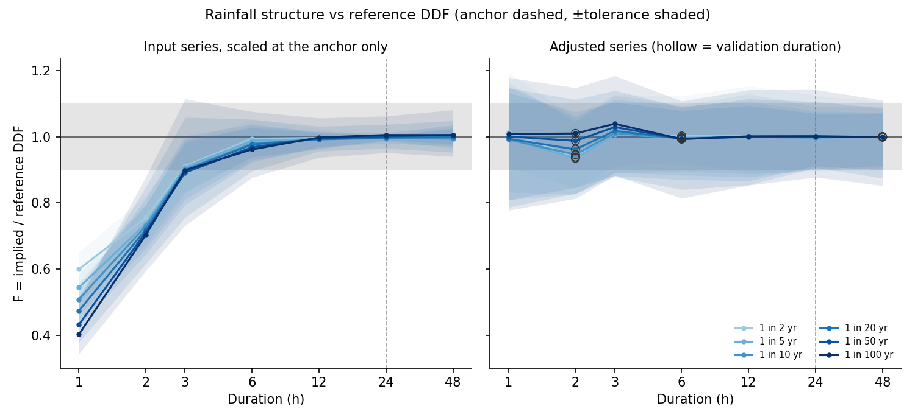
Figure 1. Ratio F of implied to reference DDF depth against duration, before (left) and after (right) adjustment; bands show 5-95% bootstrap intervals, the grey band the tolerance.
Table 1. Ratio F (implied / reference), before -> after. Role: fitted = calibration rung, check = independent validation duration.
Duration | Role | 1:2 yr | 1:5 yr | 1:10 yr | 1:20 yr | 1:50 yr | 1:100 yr
1 h | fitted | 0.59 -> 1.01 | 0.54 -> 0.99 | 0.51 -> 0.99 | 0.48 -> 0.99 | 0.45 -> 1.00 | 0.42 -> 1.01
2 h | check | 0.74 -> 0.94 | 0.73 -> 0.94 | 0.73 -> 0.95 | 0.73 -> 0.96 | 0.73 -> 0.99 | 0.73 -> 1.01
3 h | fitted | 0.89 -> 1.01 | 0.89 -> 1.01 | 0.90 -> 1.01 | 0.91 -> 1.02 | 0.92 -> 1.03 | 0.92 -> 1.04
6 h | check | 0.98 -> 1.00 | 0.98 -> 1.00 | 0.98 -> 1.00 | 0.98 -> 0.99 | 0.98 -> 0.99 | 0.98 -> 0.99
12 h | fitted | 0.99 -> 1.00 | 0.99 -> 1.00 | 0.99 -> 1.00 | 0.99 -> 1.00 | 1.00 -> 1.00 | 1.00 -> 1.00
24 h | anchor | 1.00 -> 1.00 | 1.00 -> 1.00 | 1.00 -> 1.00 | 1.00 -> 1.00 | 1.00 -> 1.00 | 1.00 -> 1.00
48 h | check | 1.00 -> 1.00 | 1.00 -> 1.00 | 1.00 -> 1.00 | 1.00 -> 1.00 | 1.00 -> 1.00 | 1.00 -> 1.00
Table 2. Depth (mm): reference / adjusted series.
Duration | 1:2 yr | 1:5 yr | 1:10 yr | 1:20 yr | 1:50 yr | 1:100 yr
1 h | 24.8 / 25.1 | 37.0 / 36.8 | 46.1 / 45.7 | 55.6 / 55.3 | 69.2 / 69.3 | 80.5 / 81.1
2 h | 35.3 / 33.2 | 49.4 / 46.2 | 58.5 / 55.3 | 66.9 / 64.3 | 77.5 / 76.5 | 85.2 / 86.0
3 h | 40.0 / 40.4 | 54.7 / 55.1 | 64.3 / 65.0 | 73.3 / 74.6 | 84.7 / 87.2 | 93.1 / 96.7
6 h | 46.2 / 46.3 | 62.5 / 62.3 | 73.5 / 73.1 | 84.2 / 83.7 | 98.4 / 97.7 | 109.2 / 108.4
12 h | 50.6 / 50.7 | 67.9 / 67.8 | 79.8 / 79.7 | 91.7 / 91.6 | 107.6 / 107.6 | 120.0 / 120.2
24 h | 53.9 / 53.8 | 71.1 / 70.9 | 82.2 / 82.0 | 92.7 / 92.6 | 106.0 / 106.0 | 115.7 / 115.9
48 h | 57.3 / 57.3 | 74.0 / 74.0 | 84.0 / 84.0 | 93.0 / 93.0 | 103.7 / 103.6 | 111.1 / 110.9
Table 3. Fitted pass-2 coefficients per calibration rung.
Rung | a | c | RMSE (log)
12h | 0.014 | -0.005 | 0.0010
1h | 0.635 | 0.119 | 0.0080
3h | 0.112 | -0.013 | 0.0045
Table 4. Ensemble spread of F (5-95% across realisations).
Duration | 1:2 yr | 1:5 yr | 1:10 yr | 1:20 yr | 1:50 yr | 1:100 yr
1 h | 0.95-1.01 | 0.95-1.06 | 0.93-1.11 | 0.92-1.16 | 0.89-1.24 | 0.87-1.31
2 h | 0.89-0.92 | 0.88-0.95 | 0.87-0.98 | 0.87-1.02 | 0.86-1.09 | 0.85-1.15
3 h | 0.99-1.03 | 0.98-1.03 | 0.96-1.03 | 0.94-1.04 | 0.90-1.05 | 0.87-1.07
6 h | 0.97-1.02 | 0.96-1.01 | 0.95-1.00 | 0.95-1.01 | 0.93-1.04 | 0.93-1.06
12 h | 0.98-1.01 | 0.99-1.02 | 0.99-1.02 | 1.00-1.01 | 0.99-1.02 | 0.99-1.03
24 h | 1.00-1.00 | 1.00-1.00 | 1.00-1.00 | 1.00-1.00 | 1.00-1.00 | 1.00-1.00
48 h | 0.99-1.00 | 0.99-1.00 | 1.00-1.00 | 1.00-1.00 | 1.00-1.01 | 1.00-1.01

5. Diagnostics
Item | Value
Storms identified | 932
Storms touching missing data (not reshaped) | 0
Storms below reference range (factor held) | 902
Storms beyond reference range (extrapolated) | 0
Storms reshaped in pass 2 | 932
Calibration durations (min) | 60,180,720
Validation durations (min) | 120,360,2880
Random seed | 42

6. Interpretation and limitations
- The adjusted series is a statistical reconstruction for design and continuous-simulation use. It reproduces the reference DDF in the annual-maximum sense; individual storms are not claimed to be the true historical point rainfall.
- No detail finer than the input's native time step is created.
- The reference DDF is taken as correct. Its own uncertainty (e.g. the Design Rainfall lower/upper bounds, reported in the consistency CSV) is not propagated into the adjustment.
- Part of the pre-adjustment deficit is the legitimate point-versus-area difference of a grid cell. If the adjusted series is to represent a catchment rather than a point, supply an areally reduced reference DDF.
- Validation durations are an internal consistency check; independent gauge records, where available, remain the preferred verification.

References
- Guerreiro, S.B., et al. (2024). Unravelling the complex interplay between daily and sub-daily rainfall extremes in different climates. Weather and Climate Extremes.
- Lavers, D.A., et al. (2022). An evaluation of ERA5 precipitation for climate monitoring. Quarterly Journal of the Royal Meteorological Society, 148, 3152-3165.
- Reder, A., et al. (2022). Characterizing extreme values of precipitation at very high resolution: an experiment over twenty European cities. Weather and Climate Extremes.
- Hosking, J.R.M. & Wallis, J.R. (1997). Regional Frequency Analysis: An Approach Based on L-Moments. Cambridge University Press.
- Weiss, L.L. (1964). Ratio of true to fixed-interval maximum rainfall. Journal of the Hydraulics Division, ASCE, 90(1), 77-82.
- Smithers, J.C. & Schulze, R.E. (2003). Design Rainfall and Flood Estimation in South Africa. WRC Report K5/1060, Water Research Commission, Pretoria.
- Ball, J., et al. (eds) (2019). Australian Rainfall and Runoff: A Guide to Flood Estimation, Books 2 and 4. Commonwealth of Australia (Geoscience Australia).
- Efron, B. & Tibshirani, R.J. (1993). An Introduction to the Bootstrap. Chapman & Hall.

